**THEEN HAJ AND UMRAH SERVICE INTERFACE DESIGN**

----------------------------------------------------------------------------------------------------------------------

https://www.nusuk.sa/about

font-family: Gotham, ZaridSans-Regular, ui-sans-serif, system-ui, -apple-system, BlinkMacSystemFont, "Segoe UI", Roboto, "Helvetica Neue", Arial, "Noto Sans", sans-serif;

font-family: Gotham-Regular, ZaridSans-Regular, sans-serif;

font-family: Displace-SemiBold, ZaridSerif-Regular, sans-serif;

----------------------------------------------------------------------------------------------------------------------



Top header == > multilingual

1. Home Icon
2. Packages
3. gallery
4. Logo
5. About us
6. Guidelines
7. Contact
8. View All Service = > button



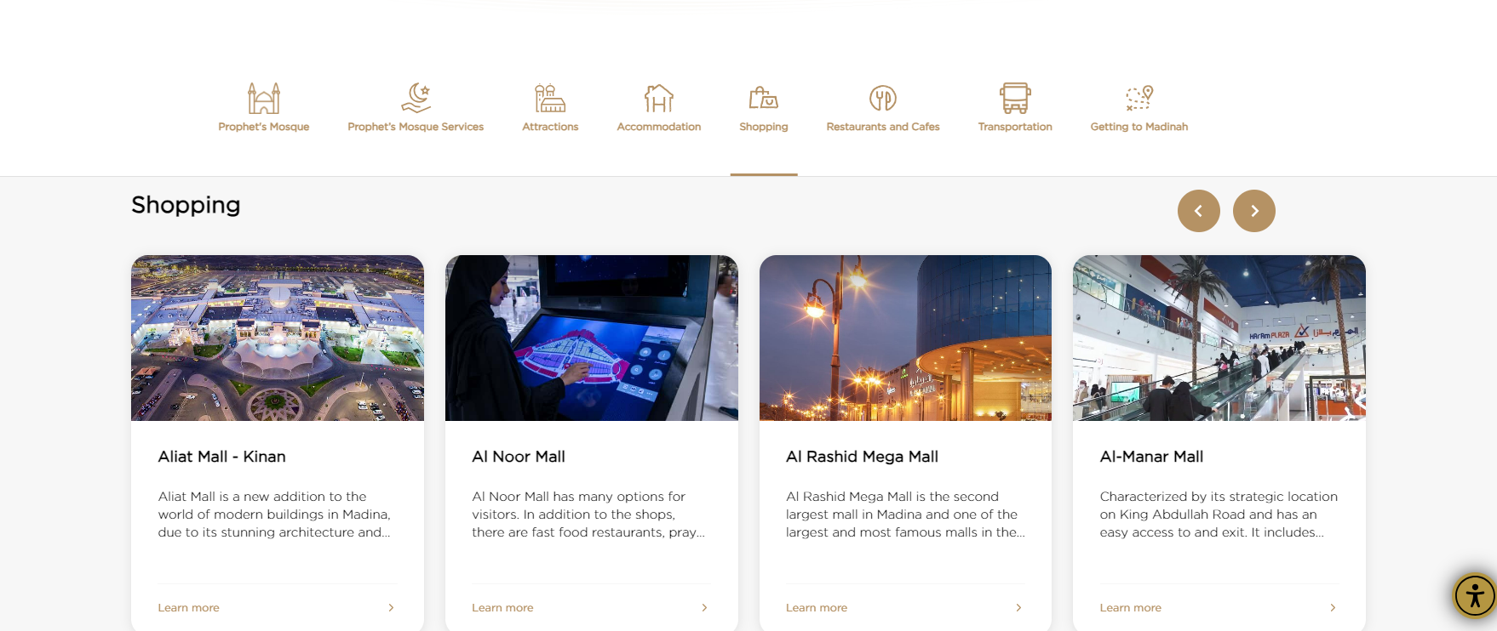

----------------------------------------------------------------------------------------------------------------------

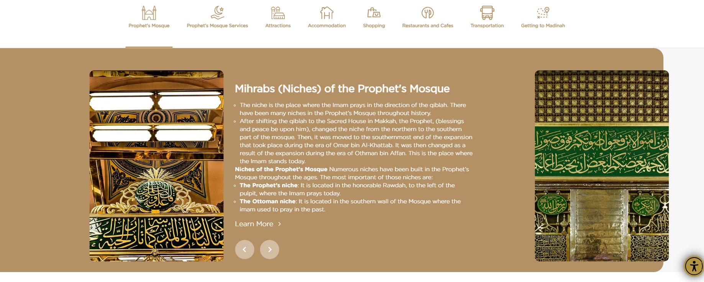

----------------------------------------------------------------------------------------------------------------------

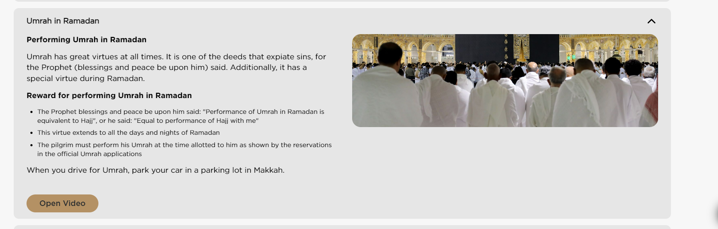

----------------------------------------------------------------------------------------------------------------------

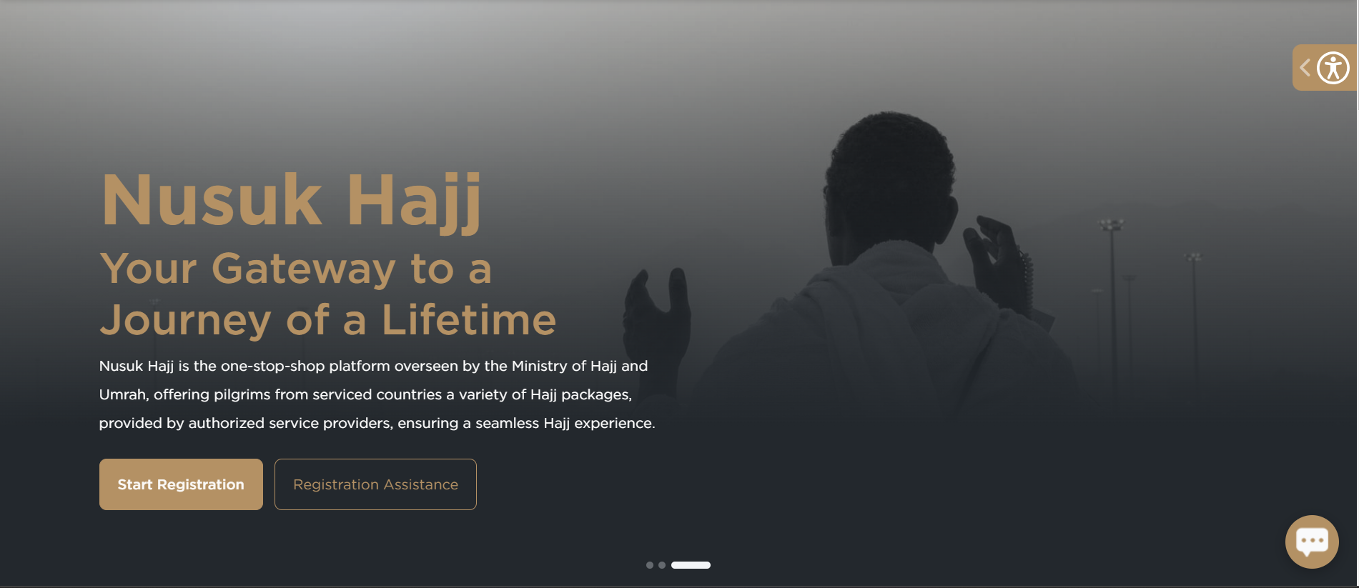

----------------------------------------------------------------------------------------------------------------------

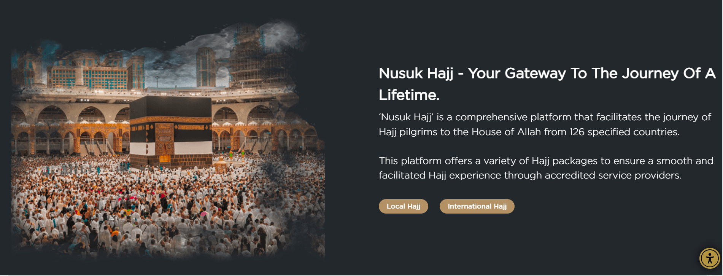

----------------------------------------------------------------------------------------------------------------------

**Packages**

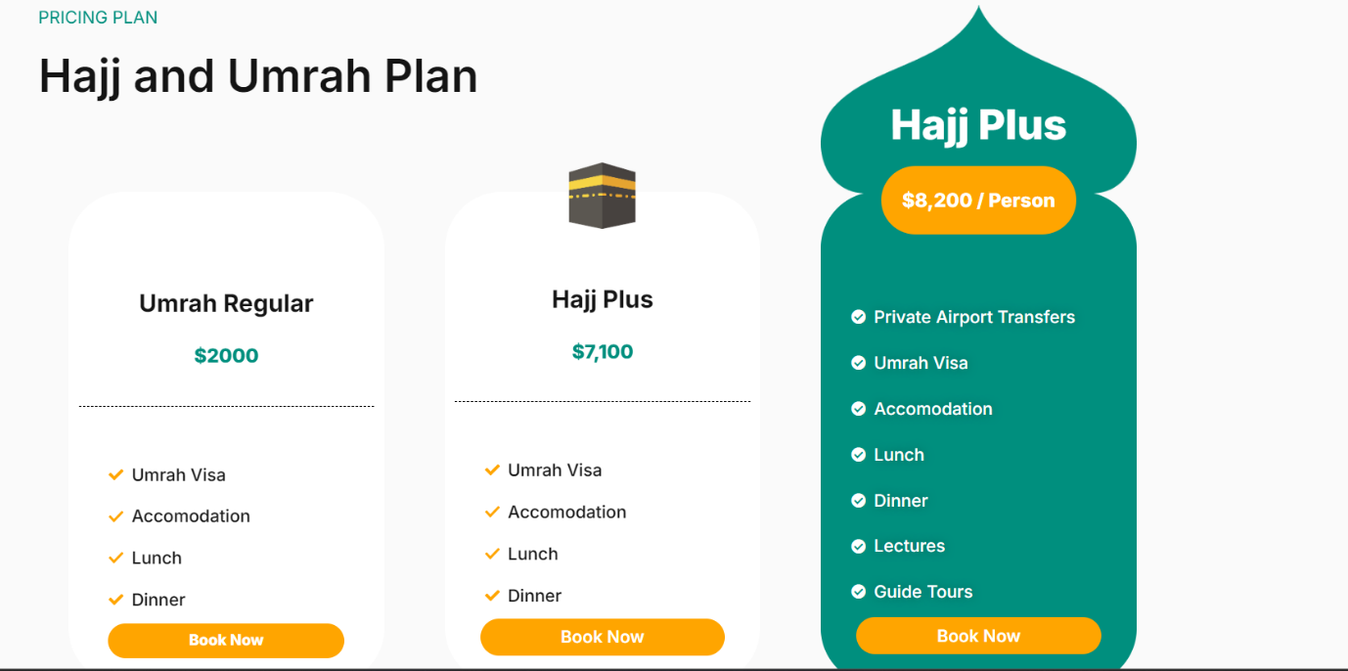

--------------------------------------------------------------------------------------------------------------------

Contact

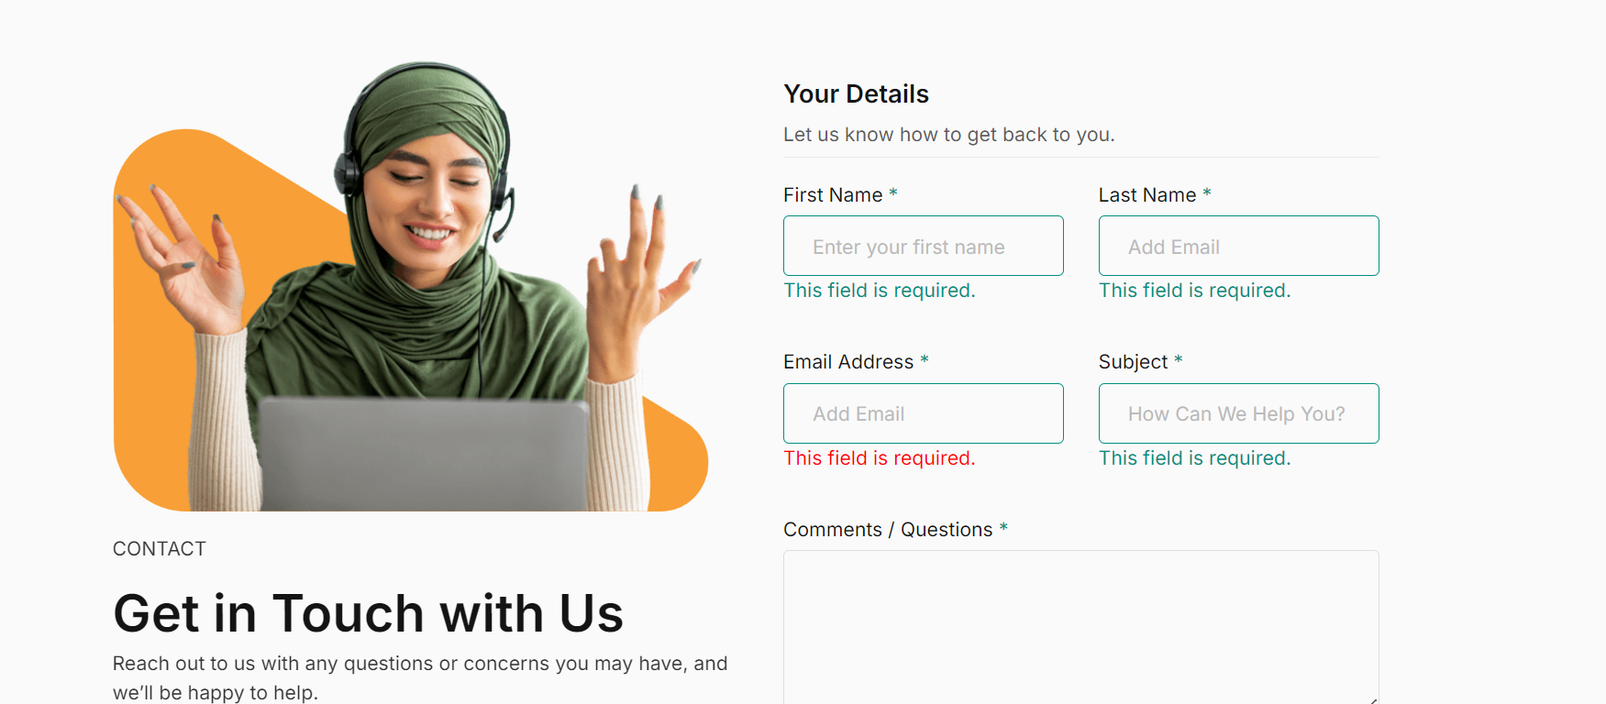  
--------------------------------------------------------------------------------------------------------------------

<https://hajj.nusuk.sa/Journey>  
  
Umrah and haji   
  
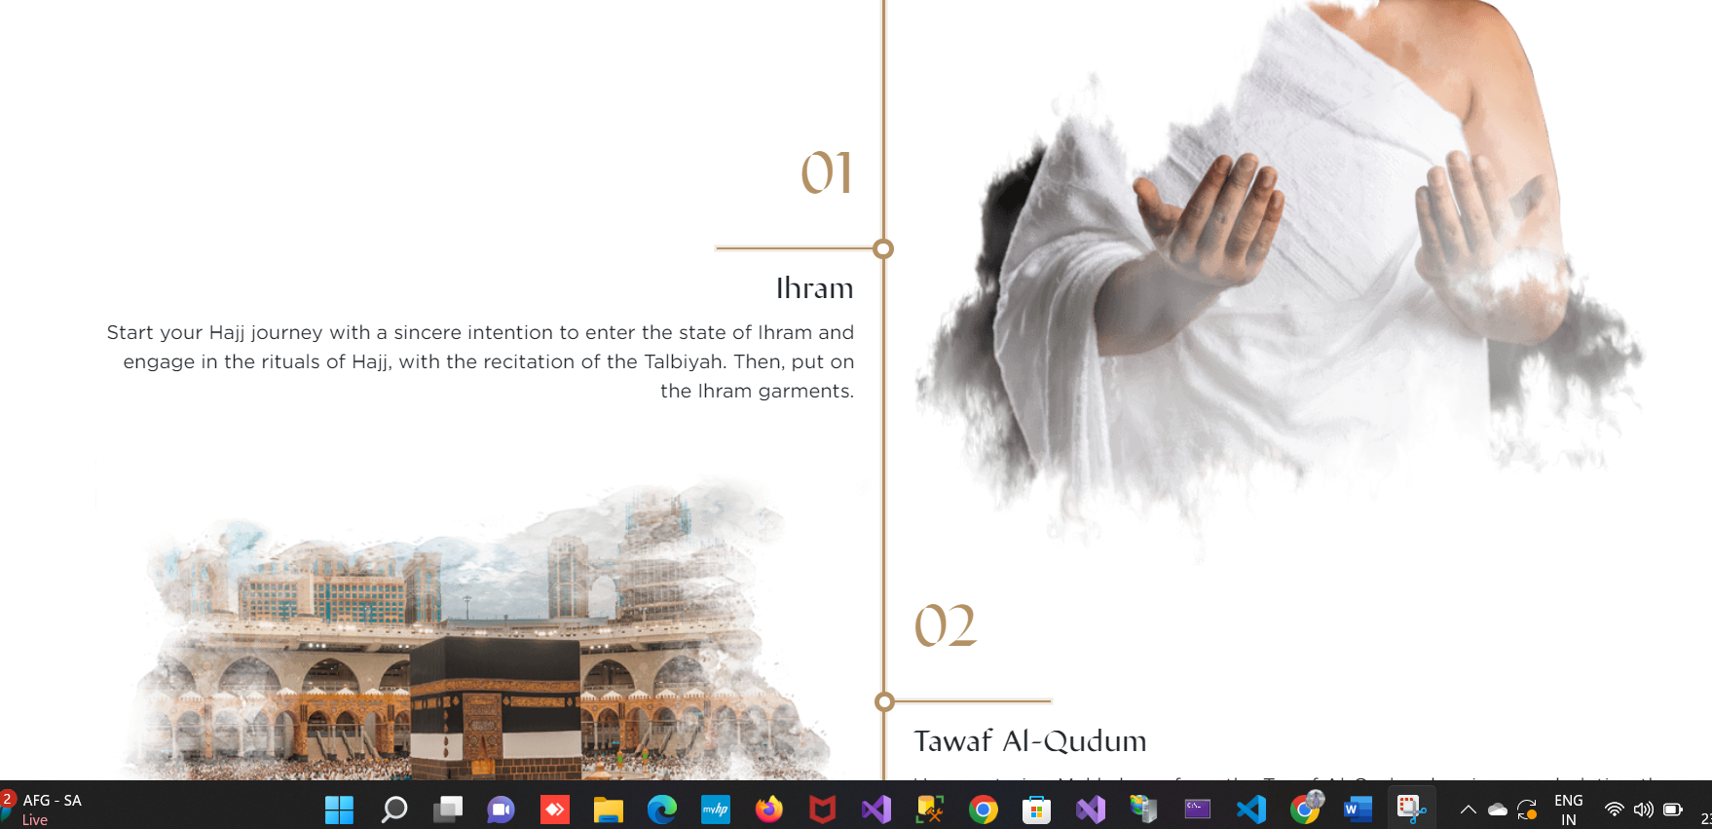

--------------------------------------------------------------------------------------------------------------------

https://hajj.nusuk.sa/PackagesCategories

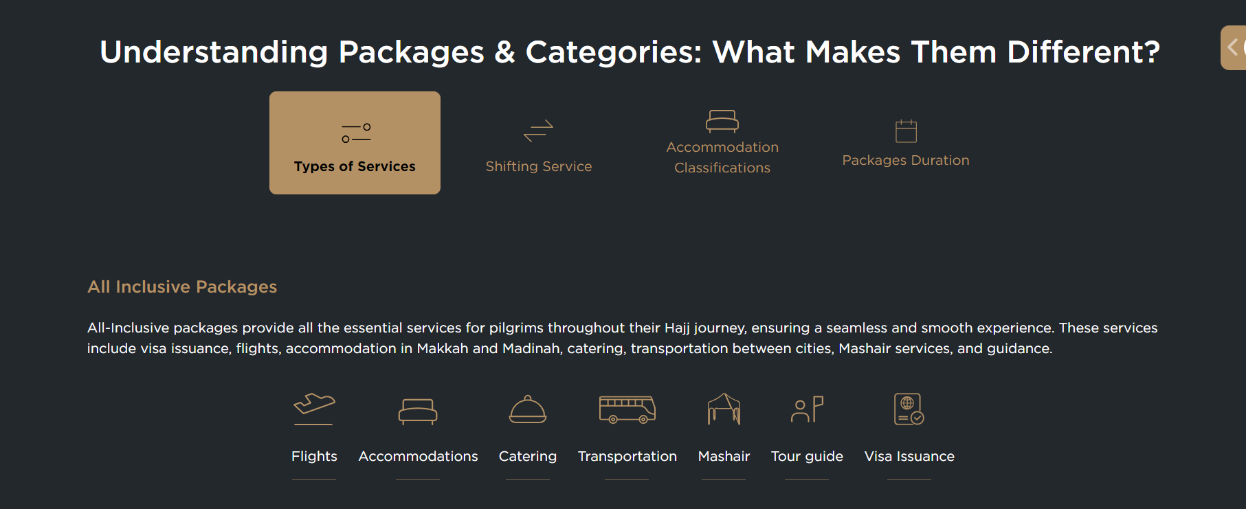

--------------------------------------------------------------------------------------------------------------------

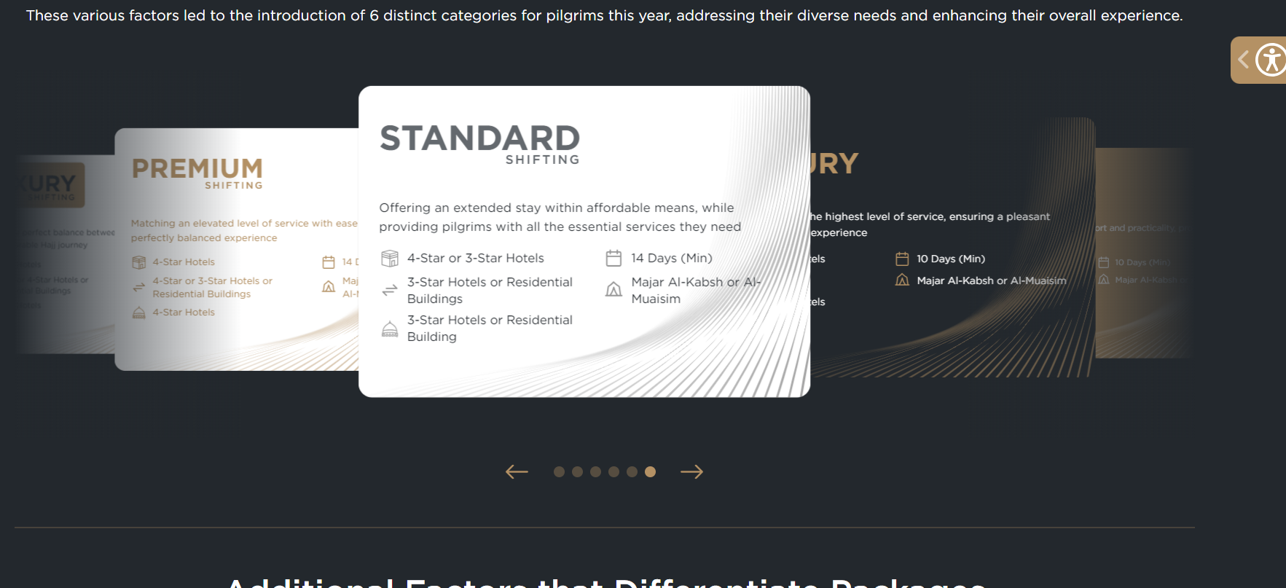

--------------------------------------------------------------------------------------------------------------------

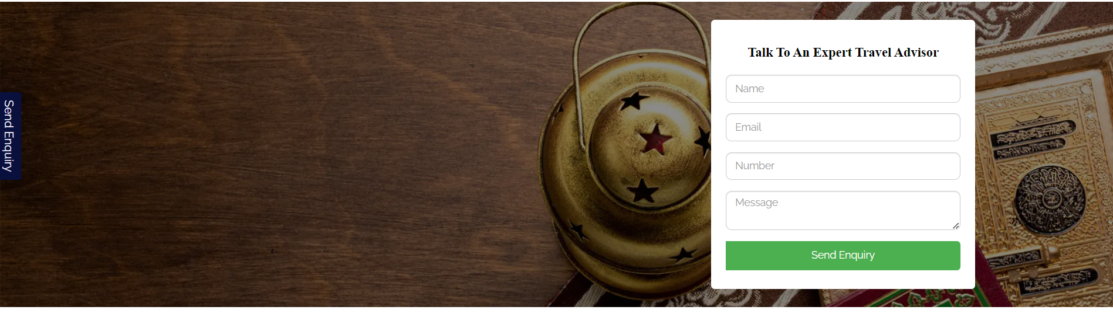

--------------------------------------------------------------------------------------------------------------------

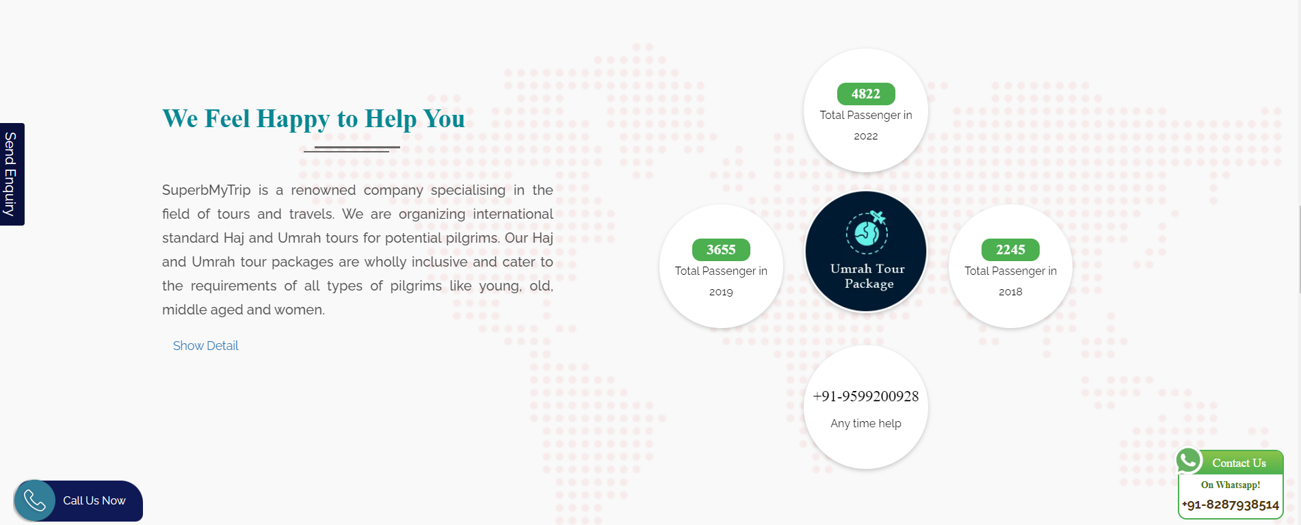

--------------------------------------------------------------------------------------------------------------------

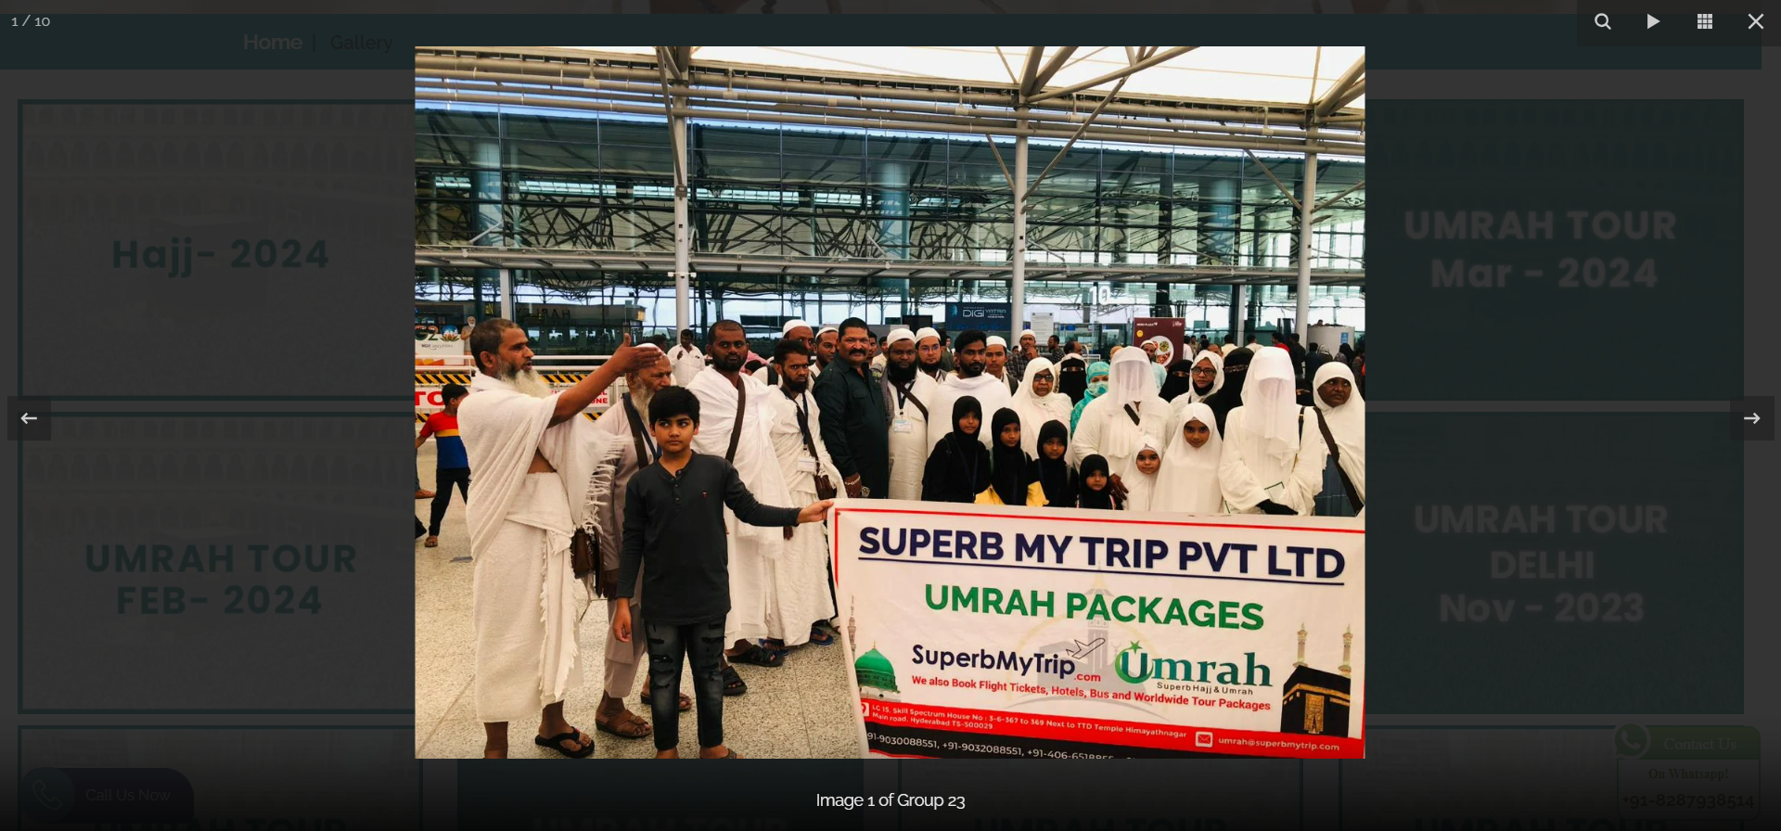

--------------------------------------------------------------------------------------------------------------------

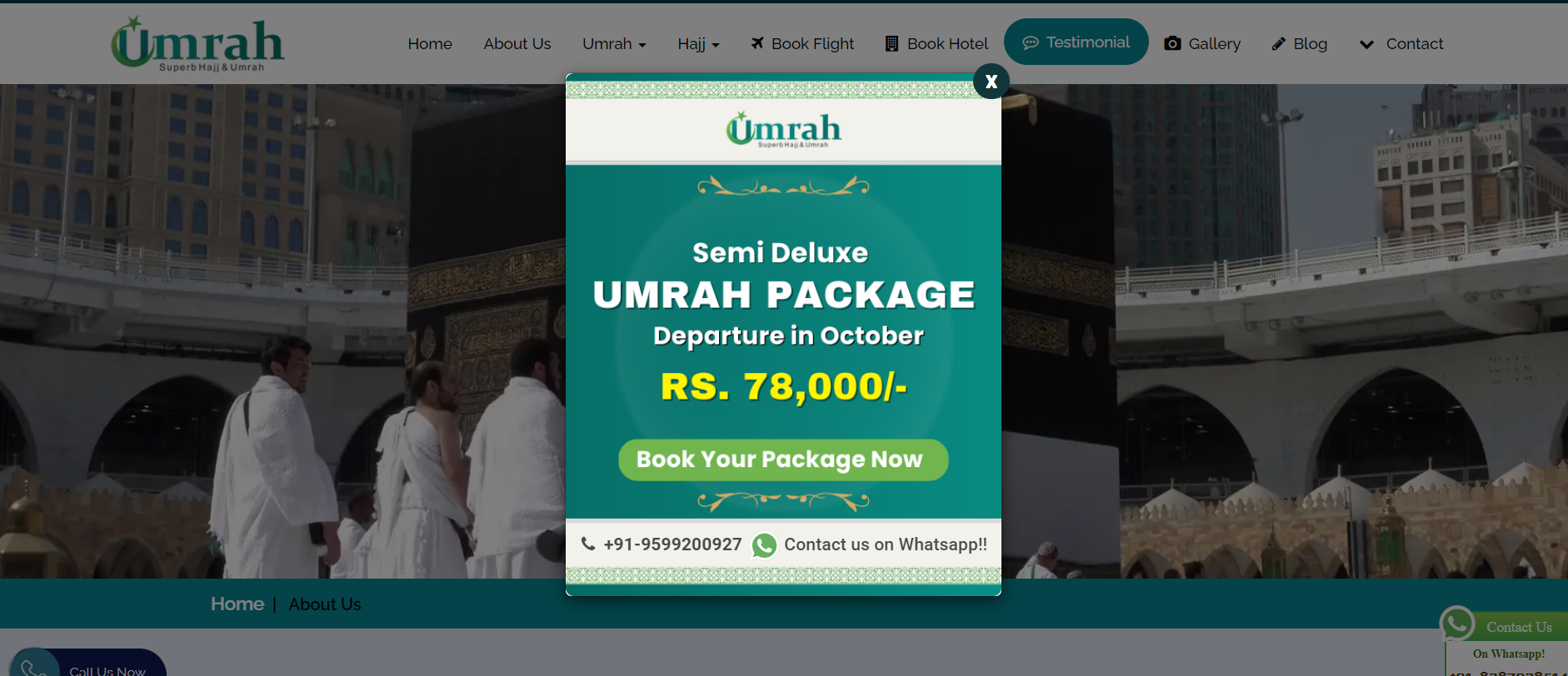

--------------------------------------------------------------------------------------------------------------------

https://www.manarhajj.com/hj/ar/index.php

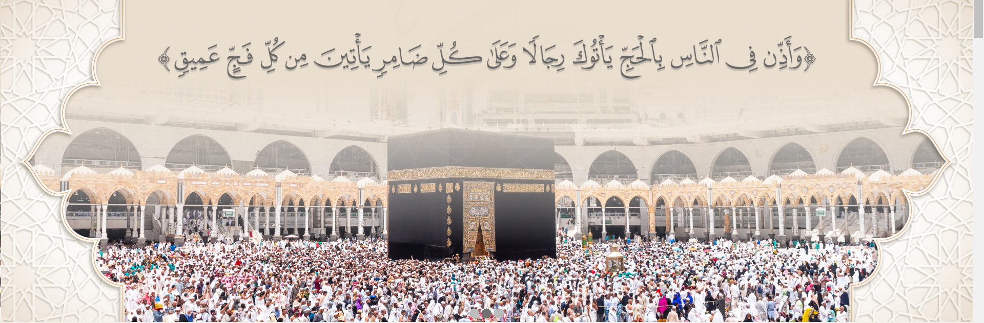

--------------------------------------------------------------------------------------------------------------------



--------------------------------------------------------------------------------------------------------------------

https://umrahbysaudia.com/en-US



